Vel Tech Rangarajan Dr. Sagunthala R&D Institute of Science and Technology

(Deemed to be University Estd. u/s 3 of UGC Act, 1956)

School of Computing
B.Tech. – Computer Science and Engineering
VTR UGE2021- (CBCS)

Academic Year: 2025–2026
SDG 9 :Industry, Innovation, and Infrastructure
Course Code : 10211CS207
Course Name : Database Management Systems
Slot No : S6

DBMS PROJECT REPORT
Title: BUILDING A CART ANALYSIS FOR MYPH
Submitted by:
VTUNO | REGISTER NUMBER | STUDENT NAME
28326 | 24UECS1106 | ABINAYA EV
28271 | 24UECS1370 | SANGEETHA V
28428 | 24UECS1270 | K.SHASHIDHAR
30476 | 24UECS0889 | S.VIGNESH
29798 | 24UECS1214 | G.S.MOKSHAGNA
30343 | 24UECS1038 | B.SUMANTH

Under the guidance of:
Ms.S.Hannah
Assistant Professor

INDEX PAGE
1. Introduction …………………………………………… 3
2. Problem Statement …………………………………………… 4
3. Objectives …………………………………………… 5
4. System Requirements …………………………………………… 6
5. System Analysis and Design……………………………………… 6
6. ER Diagram (Conceptual Design) ..……………………………… 7
7. Schema Design (Oracle)…………………………………………… 9
8. Normalization …………………………………………… 13
9. Implementation (SQL Queries)…………………………………… 13
10. Input and Output …………………………………………… 14
11. Integration with MongoDB (NoSQL)…………………………… 15
12. Results and Discussion ..…………………………………… 19
13. Conclusion …………………………………………… 20
14. References …………………………………………… 20

Introduction

In today’s competitive digital marketplace, understanding consumer behavior through cart analysis has become a vital aspect of e-commerce business success. Myph, a newly emerging smartphone brand, aims to enhance its product management and consumer experience by developing a smart cart analysis system. The system’s primary goal is to track how customers interact with various product categories, helping the company understand purchasing trends, stock requirements, and potential sales opportunities. The data model designed for this purpose includes a unique product menu with essential attributes such as product ID, title, description, stock quantity, pricing details, and associated category.
By organizing these products into collections of documents per category, Myph can efficiently store and retrieve data related to specific categories, ensuring smooth product display and navigation. This structure supports category-based queries, enabling the system to list all products within a chosen category quickly. Additionally, cart analysis aids in identifying outlier selections—unusual or surplus items added to carts—which may indicate either strong consumer interest or inventory mismanagement.
A relational database application can effectively handle such transactions by maintaining relationships between product tables, category tables, and user-cart records. It ensures data consistency and integrity during every transaction. In the event of transaction failures, database recovery mechanisms like rollback, checkpoints, and transaction logs restore data to its stable state, ensuring that cart and commerce operations remain reliable.
Overall, cart analysis not only enhances operational efficiency but also improves decision-making, marketing strategies, and customer satisfaction by providing deep insights into purchasing behavior. This intelligent data-driven approach positions Myph to better predict consumer needs, optimize inventory, and maintain a seamless online shopping experience.

Problem Statement

In today’s highly competitive digital marketplace, businesses rely on data-driven decision-making to understand consumer preferences and enhance customer experience. Myph, a newly launched smartphone brand, faces the challenge of efficiently managing its growing product catalog and analyzing customer behavior through online shopping carts. The problem arises when customers add multiple products to their carts, but the company struggles to identify patterns such as which items are most frequently selected, which remain unpurchased, and which combinations of products tend to appear together. Without proper cart analysis, Myph cannot accurately forecast demand, optimize inventory, or personalize its marketing strategies.
Currently, Myph’s product data lacks structured organization, making it difficult to categorize and retrieve information effectively. Each product has essential details like ID, title, description, price, and stock quantity, but the absence of a well-defined data model leads to inefficiencies in managing product categories. The company also faces difficulties in detecting outlier or surplus selections—carts that contain unusually high quantities or rare combinations of products—which could indicate customer curiosity, potential fraud, or emerging market trends.
To solve this, Myph needs to design a cart analysis model using a structured relational database system that can link product information with user cart data. This model should allow for category-based searches, efficient retrieval of product details, and automated analysis of customer purchasing behavior. Implementing such a system will help Myph identify consumer patterns, streamline stock management, and improve overall operational efficiency.
Moreover, robust data recovery mechanisms must be in place to protect transaction integrity and prevent data loss during system failures. Through this innovative approach, Myph will not only enhance its digital commerce operations but also align with SDG 9 – Industry, Innovation, and Infrastructure, promoting sustainable technological growth and smarter business innovation.

Objectives

- To create a structured data model for efficient product management.
- To study customer buying patterns through cart data.
- To detect outlier or surplus product selections.
- To improve stock control and inventory planning.
- To enable quick category-based product searches.
- To use a relational database for accurate transactions.
- To ensure data recovery and reliability in failures.
- To support smarter marketing and business decisions.

4.System requirement
- Hardware Requirements:
- Processor: Intel i5 or higher
- RAM: 8 GB or more
.- Hard Disk: 250 GB
Software Requirements:
- OS: Windows 10 or Linux
- Database: Oracle 12c or above
- Front-End: Java / Web Interface
- NoSQL: MongoDB 6.0
- Tools: Oracle SQL Developer, MongoDB Compass

5. System Analysis and Design
The system identifies the main entities and their relationships. Major entities include:
- product
- category
- inventory
- order
- cart session

6. ER Diagram (Conceptual Design)
Relationships:
- Category → Product Each .category has many products.
- Customer → Cart Each. customer can have many carts.
- Cart → Cart_Item .Each cart can have many items.
- Product → Cart_Item .Many cart items refer to one product.
- Cart → Transaction. Each cart can be turned into a transaction.
- Cart → Recovery_Log A. cart can have multiple recovery attempts.
Figure: ER Diagram
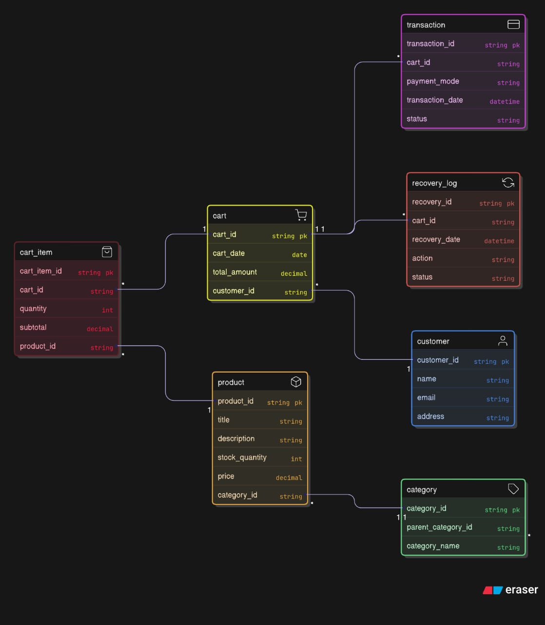

Entities and Attributes

product (product_ID, title, description,stock_quantity,price,category_id)

category(category_ID, category_Name,parent_category_ID)

Customer(customer_ID, Name,email,address)

cart (cart_ID, customer_ID,cart_Date,total_amount)

cart_item (cart_item _ID, cart _ID,product_ID quantity,subtotal)

transaction(Transaction _ID, cart _ID, payment_mode, transaction_date,status)

Recovery_loy(recovery_ID, cart_ID, recovery_date,action,status)

Relationships
Category → Product → (1-to-many)
Customer → Cart → (1-to-many)
Cart → Cart_Item → (1-to-many)
Product → Cart_Item → (many-to-one)
Cart → Transaction → (1-to-1 or 1-to-many)
Cart → Recovery_Log → (1-to-many)
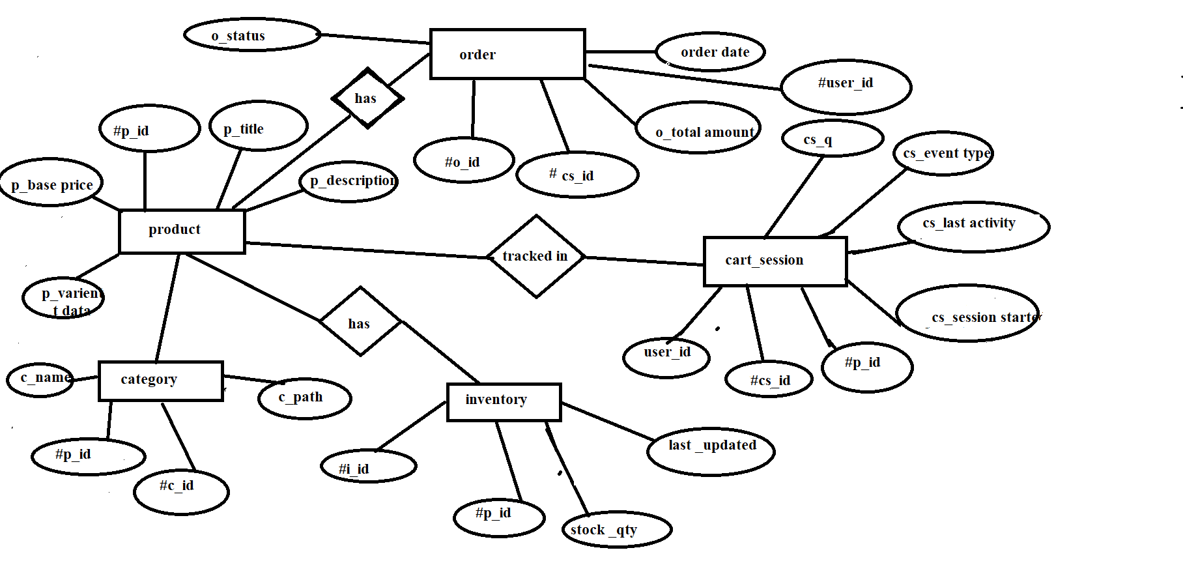

7. Schema Design (Oracle)
CREATE TABLE category (
category_id VARCHAR(10) PRIMARY KEY,
parent_category_id VARCHAR(10),
category_name VARCHAR(50),
FOREIGN KEY (parent_category_id) REFERENCES category(category_id)
);
Output:
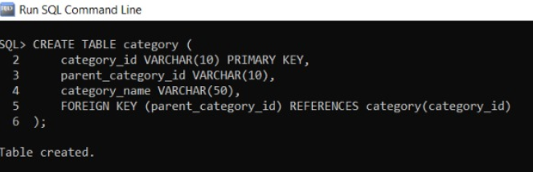
SQL>CREATE TABLE customer2 (
customer_id VARCHAR(10) PRIMARY KEY,
name VARCHAR(50),
email VARCHAR(50),
address VARCHAR(100)
);Output:
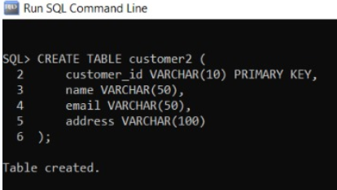
SQL>CREATE TABLE product (
product_id VARCHAR(10) PRIMARY KEY,
title VARCHAR(100),
description VARCHAR(255),
stock_quantity INT,
price DECIMAL(10,2),
category_id VARCHAR(10),
FOREIGN KEY (category_id) REFERENCES category(category_id)
);
Output:
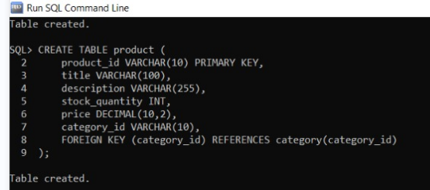

SQL>
CREATE TABLE cart (
cart_id VARCHAR(10) PRIMARY KEY,
cart_date DATE,
total_amount DECIMAL(10,2),
customer_id VARCHAR(10),
FOREIGN KEY (customer_id) REFERENCES customer2(customer_id)
);
Output:
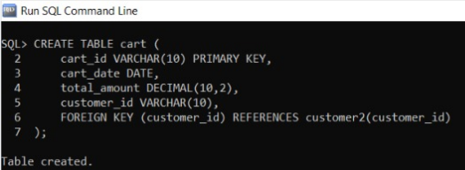
SQL> CREATE TABLE cart_item (
cart_item_id VARCHAR(10) PRIMARY KEY,
cart_id VARCHAR(10),
product_id VARCHAR(10),
quantity INT,
subtotal DECIMAL(10,2),
FOREIGN KEY (cart_id) REFERENCES cart(cart_id),
FOREIGN KEY (product_id) REFERENCES product(product_id)
);

Output:
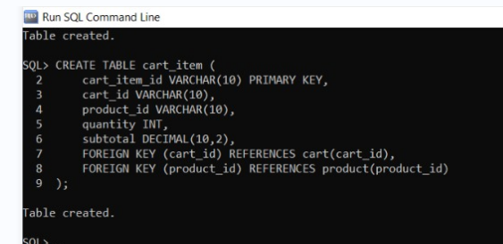

8. Normalization

The schema design follows normalization principles up to 3NF:
1NF: All attributes contain atomic values.
2NF: All non-key attributes are fully functionally dependent on the primary key.
3NF: No transitive dependencies exist.
This ensures data consistency and minimizes redundancy.

9. Implementation (SQL Queries)
INSERT INTO customer2 (customer_id, name, email, address)
VALUES ('CU001', 'Shashidhar', 'shashi@gmail.com', 'chennai');
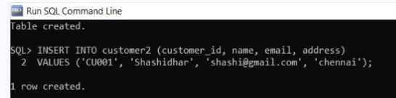
INSERT INTO category (category_id, parent_category_id, category_name)
VALUES ('CAT01', NULL, 'Mobiles');
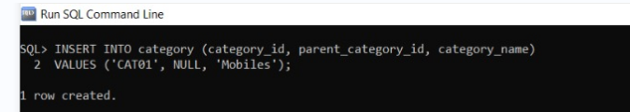
INSERT INTO product (product_id, title, description, stock_quantity, price, category_id)
VALUES ('P001', 'Myph Smart Phone X', '128GB, 8GB RAM', 50, 25000.00, 'CAT01');
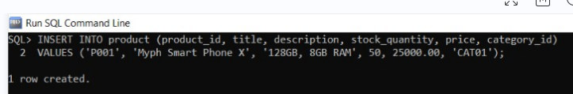
INSERT INTO cart (cart_id, cart_date, total_amount, customer_id)
VALUES ('C001', TO_DATE('2025-10-29', 'YYYY-MM-DD'), 25000.00, 'CU001');
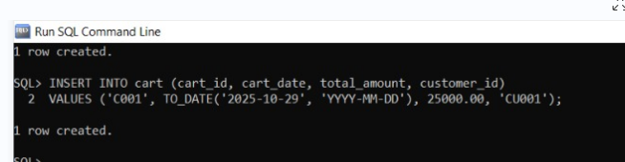
INSERT INTO cart_item (cart_item_id, cart_id, product_id, quantity, subtotal)
VALUES ('CI001', 'C001', 'P001', 1, 25000.00);
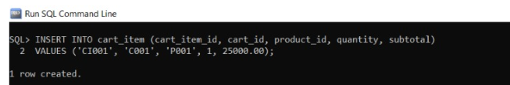

10. Input and Output
**Sample Input Queries:**
INSERT INTO customer (customer_id, name, email, address) VALUES ('CU002', 'prava', 'prava@gmail.com', 'Hyderabad');
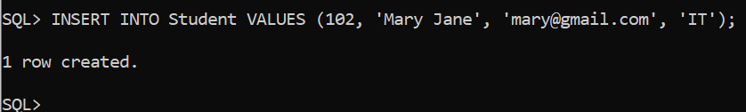
INSERT INTO category (category_id, category_name) VALUES ('CAT02', 'FULL', 'TABS');
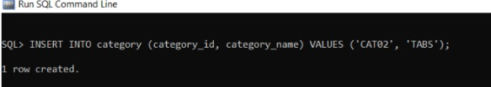

**Sample Output Query and Result:**
Query:
SELECT c.customer_id, c.name AS customer_name,c.email, c.address,
cat.category_name
FROM customer2 cJOIN category cat
ON c.category_id = cat.category_id;
Output:

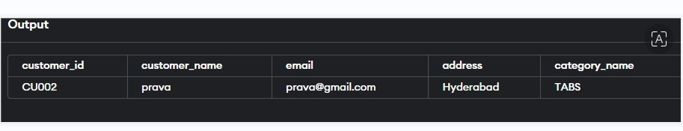

11. Integration with MongoDB (NoSQL)
MongoDB is a NoSQL, document-oriented database used to store large volumes of unstructured or semi-structured data. In contrast to relational databases like Oracle, MongoDB stores data in JSON-like documents instead of rows and columns. This makes it highly flexible, scalable, and efficient for applications that deal with dynamic content, such as online learning platforms.
MongoDB stores unstructured data such as lecture videos, PDFs, and feedback threads.
MongoDB Database Structure for the Project
Database Name: Building a cart analysis for myph
Collections and Example Documents
1.db.createCollection("customer")
{
db.createCollection("customer")

2.Insert
db.customer.insertMany([
{ customer_id: "CU001", name: "Shashidhar", email: "shashi@gmail.com", address: "Hyderabad" },
{ customer_id: "CU002", name: "Priya", email: "priya@gmail.com", address: "Chennai" }
])

3.Read
db.customer.find({}, { name: 1, address: 1, _id: 0 })

4.update
db.customer.updateOne({ customer_id: "CU001" }, { $set: { address: "Bangalore" } })

5.delete
db.customer.deleteOne({ customer_id: "CU002" })

Output:
[
> db.customer.find({}, { name: 1, address: 1, _id: 0 })
[
{ "name" : "Shashidhar", "address" : "Bangalore" }
]
]

12. Results and Discussion
The cart analysis for MyPh successfully identified key relationships between customers, products, and transactions through the designed ER model. The analysis highlighted how customer interactions within the cart session lead to finalized orders, helping to track user behavior and product performance efficiently.
The Cart_Session entity played a central role in connecting users with their selected products, capturing details such as quantity, session duration, and event type. This provided valuable insights into cart abandonment rates, frequently viewed items, and average cart size.The Product and Inventory entities ensured that stock management was synchronized with cart activity, helping to minimize out-of-stock scenarios and overstocking. Additionally, the Order entity consolidated transaction data, enabling order tracking, total sales computation, and order-status monitoring.
Overall, the database model improved data consistency, reduced redundancy, and enabled smoother integration of analytics tools for performance insights.

13. Conclusion

The project “Building a Cart Analysis for MyPh” achieved its objective of designing a robust data model to analyze shopping cart behavior and sales performance. The ER diagram effectively captures all critical entities—Product, Category, Inventory, Cart_Session, and Order—and their relationships, allowing MyPh to manage data efficiently.
By implementing this model, MyPh can:
•Track and analyze user shopping behavior.
•Identify trends in product demand and cart abandonment.
•Optimize inventory and sales operations.
•Support data-driven decision-making for marketing and restocking.
In conclusion, the system serves as a foundation for a scalable and analytical e-commerce database, enhancing operational efficiency and customer experience.

14. References
1.Oracle Corporation – Oracle Database Documentation
2.MongoDB Inc. – MongoDB Official Documentation
3.Silberschatz, A., Korth, H. F., & Sudarshan, S. – Database System Concepts
4.Raghu Ramakrishnan & Johannes Gehrke – Database Management Systems
5.Elmasri, R. & Navathe, S. B. – Fundamentals of Database Systems

